2/23/2023

Reyad Hamza

Assignment 1 Data Visualization

Bootcamp

**Policies and Procedures**

**What policies need to be adhered to when working with data?**

When working with data, it is important to adhere to various policies to ensure that the data is accurate, secure, and used in an ethical manner. Here are some of the key policies to consider:

1. Data protection and privacy policies: These policies are designed to protect personal information and ensure that it is collected, processed, and stored in a secure and responsible way. Adhering to these policies may involve obtaining consent from individuals, implementing security measures to protect data, and complying with relevant laws and regulations such as GDPR or HIPAA.
2. Data retention policies: These policies define how long data should be kept and when it should be deleted. Adhering to these policies is important to ensure that data is not kept longer than necessary, which can increase the risk of data breaches or other security incidents.
3. Data access and sharing policies: These policies outline who is authorized to access and share data, and under what circumstances. Adhering to these policies is important to prevent unauthorized access or misuse of data.
4. Data quality policies: These policies establish guidelines for ensuring the accuracy, completeness, and consistency of data. Adhering to these policies can help ensure that data is reliable and can be used for decision-making and other purposes.
5. Ethical data use policies: These policies outline principles for using data in an ethical and responsible manner, such as avoiding bias, protecting individual rights, and being transparent about data use.

In general, when working with data, it is important to be mindful of the potential risks and implications of data use, and to implement policies and practices that prioritize accuracy, security, and ethical considerations.

In conclusion, working with data requires adherence to various policies to ensure that data is accurate, secure, and used in an ethical manner. These policies may include data protection and privacy policies, data retention policies, data access and sharing policies, data quality policies, and ethical data use policies. By implementing these policies and practices, individuals and organizations can minimize the risk of data breaches, protect individual rights and privacy, and use data for decision-making and other purposes in a responsible and ethical manner.

**Why these policies need to be adhered to while you are using this data?**

Adhering to data policies is essential for several reasons:

1. Protecting individual rights and privacy: Data policies, such as data protection and privacy policies, are designed to protect individual rights and privacy. By adhering to these policies, you can ensure that personal information is collected, processed, and stored in a secure and responsible manner, and that individuals have control over their data.
2. Ensuring accuracy and reliability: Data quality policies ensure that data is accurate, complete, and consistent, which is important for making informed decisions based on the data. Adhering to these policies can help ensure that the data is reliable and can be used with confidence.
3. Mitigating risks: Data breaches and other security incidents can have significant consequences for individuals and organizations. Adhering to data access and sharing policies can help mitigate these risks by ensuring that data is only accessed by authorized individuals and used for legitimate purposes.
4. Complying with laws and regulations: Data policies may also be required by law or regulation, such as the GDPR or HIPAA. Adhering to these policies is important to avoid legal and regulatory penalties and to maintain compliance with applicable laws.

**Why it is important to be aware of these rules as a data analyst?**

As a data analyst, it is important to be aware of these rules and policies because you are responsible for handling and analysing data. Your actions can have a significant impact on data quality, accuracy, and security. Here are a few reasons why it is important for data analysts to be aware of these rules:

Data quality: As a data analyst, you are responsible for ensuring the quality and accuracy of the data you are working with. Adhering to data quality policies can help ensure that the data is reliable and can be used with confidence.

Data security: Data breaches and other security incidents can have significant consequences for individuals and organizations. As a data analyst, you may have access to sensitive data, and it is important to adhere to data access and sharing policies to mitigate the risk of security incidents.

Legal and regulatory compliance: Adhering to data policies is essential for complying with laws and regulations, such as the GDPR or HIPAA. As a data analyst, you may be responsible for ensuring that data handling practices comply with these laws and regulations.

Ethical data use: Adhering to ethical data use policies is important for ensuring that data is used in a responsible and ethical manner. As a data analyst, you have a responsibility to avoid bias, protect individual rights and privacy, and be transparent about data use.

In summary, being aware of data policies is important for data analysts to ensure data quality, security, legal and regulatory compliance, and ethical data use. By adhering to these policies, data analysts can use data in a responsible and ethical manner, and help mitigate risks associated with data handling and analysis.



**GDP Tasks**

1. **Set a password to protect the workbook**

Go to **review** – **Protect workbook** – **Enter password** – **Press ok** - **Re-enter password** **to proceed** – **Press ok**. My password is (12345).



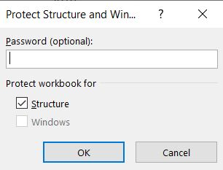

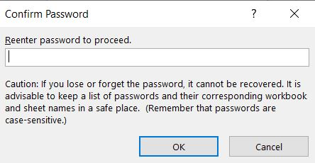

1. **Highlight column C and change the data to display in British Pound symbol**

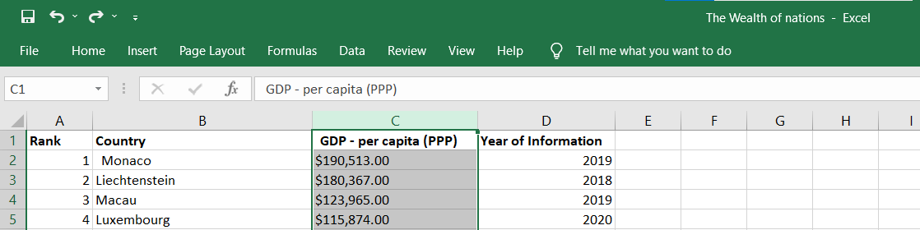

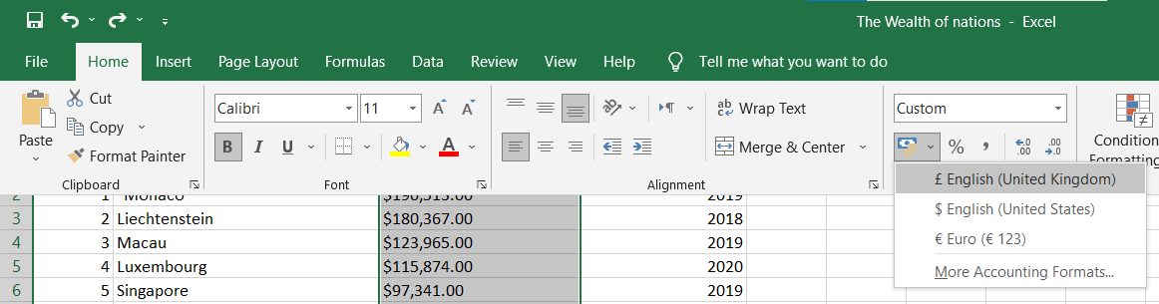

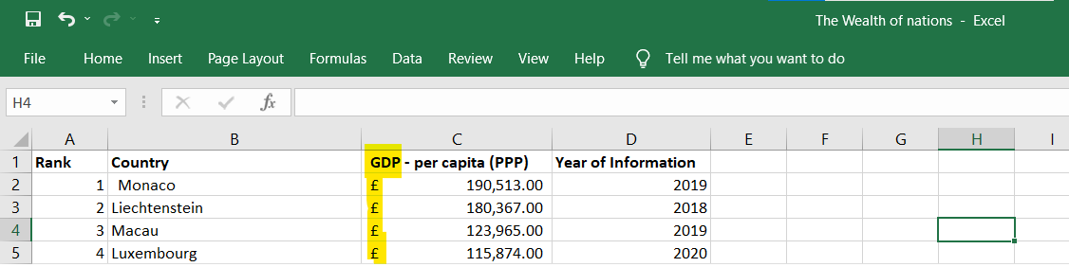

1. **Turn the GDP sheet into a table.**

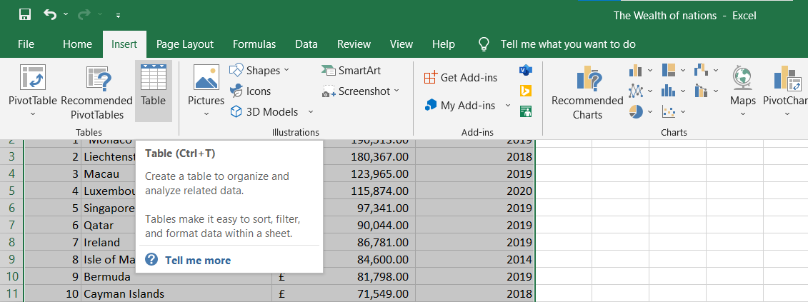

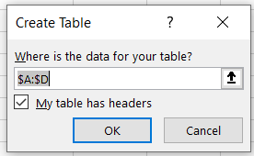



1. **Filter the table to display only the information for 2019**

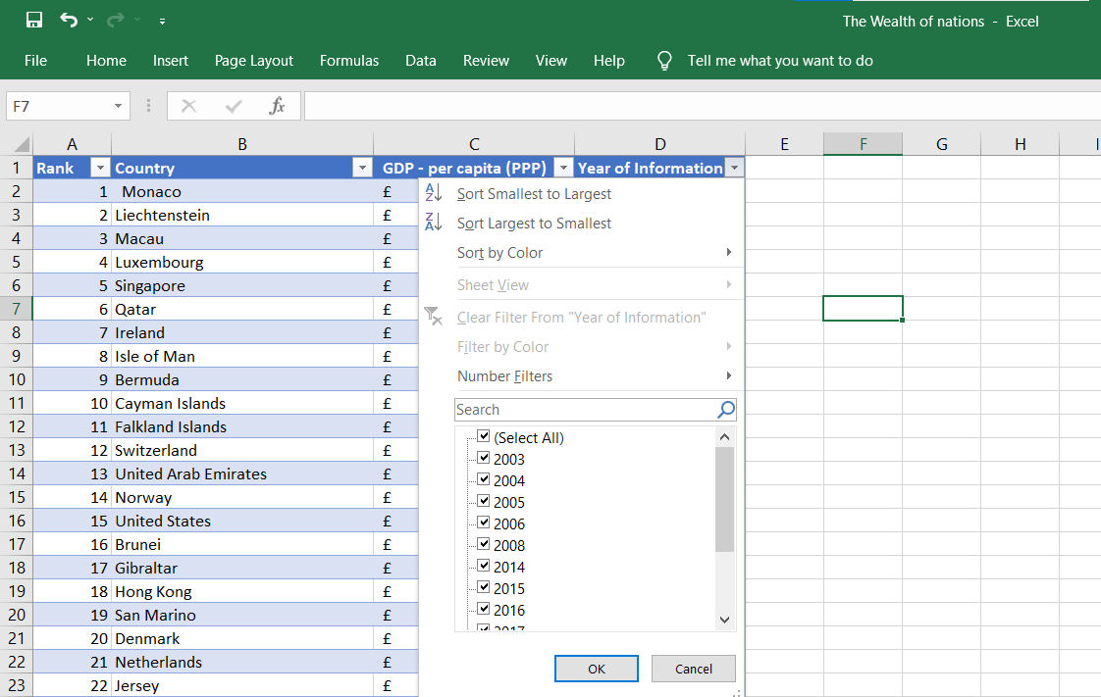

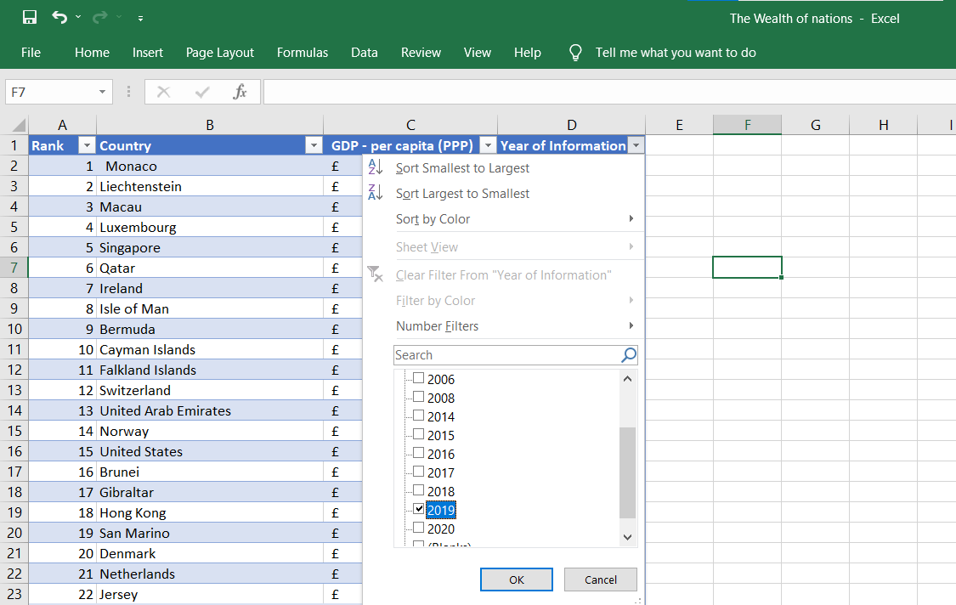

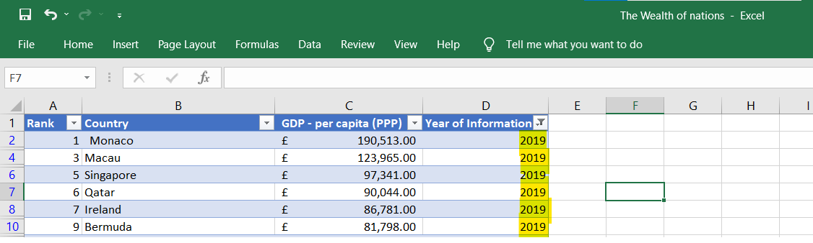

1. **Next create a chart that will only display the following data ‘Rank, Country and GDP - per capita (PPP). The chart can be anything as long as it is suitable.**

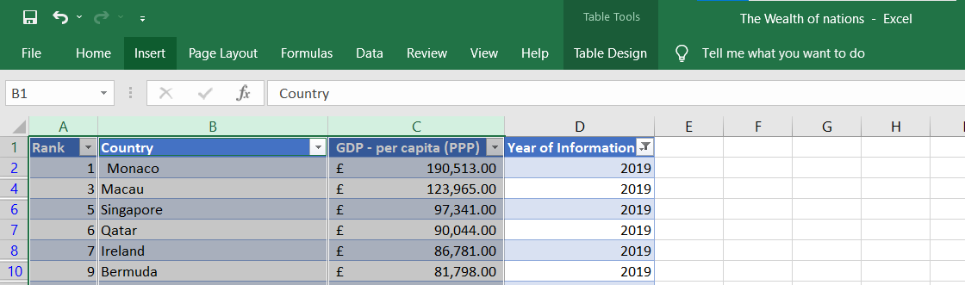

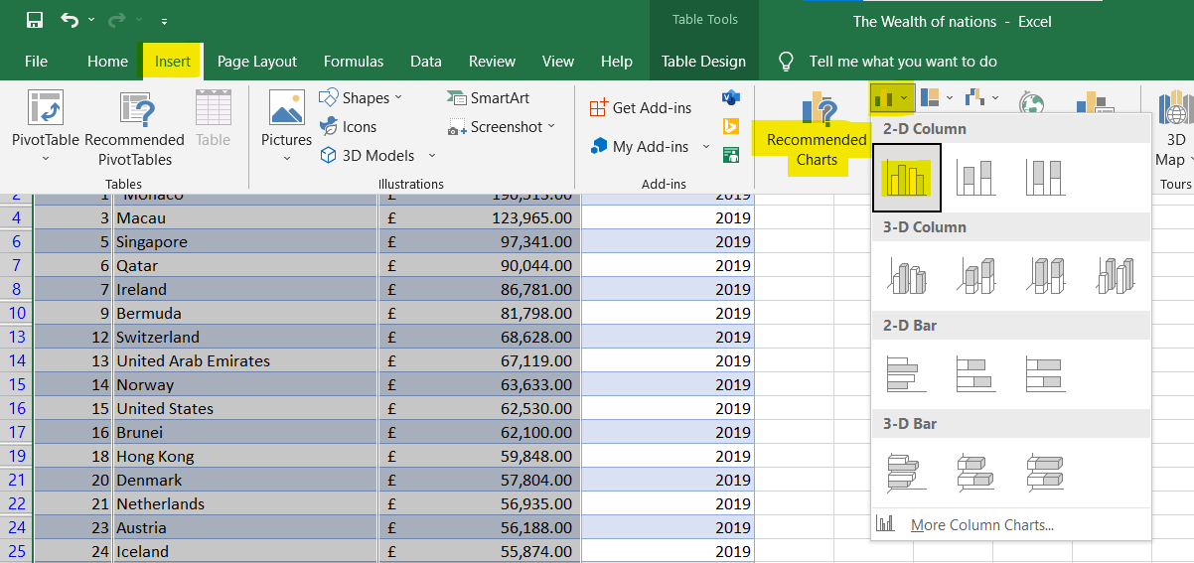

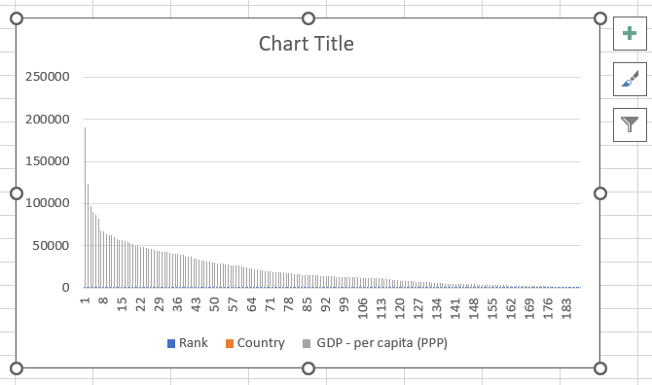

1. **Using your creative skills edit the chart** 
   1. Add a title
   2. Add X and Y axis labels
   3. Make the chart visually pleasing

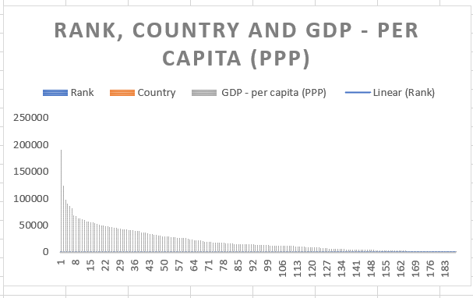

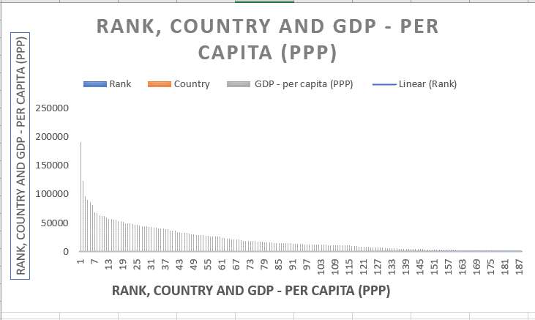

1. **Move the chart to a new sheet tab and label with a suitable name**

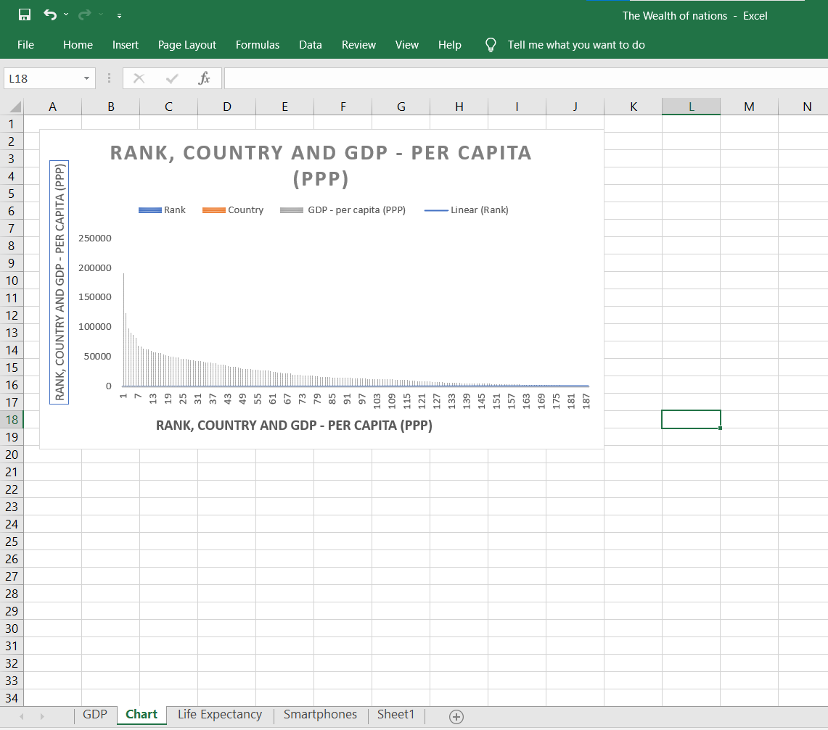

1. **Create a sort for the top 20 highest ranking counties**

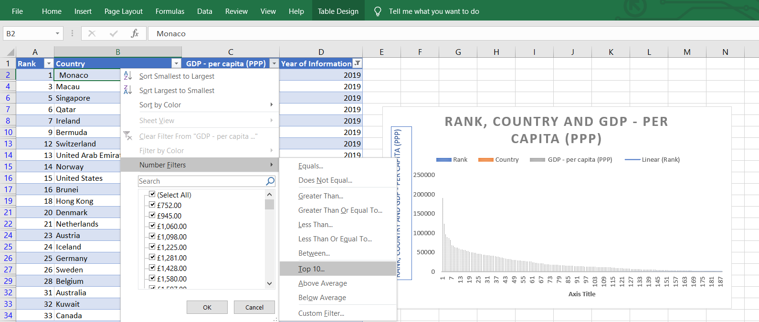

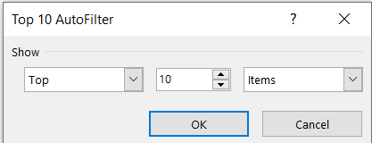

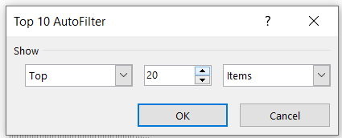

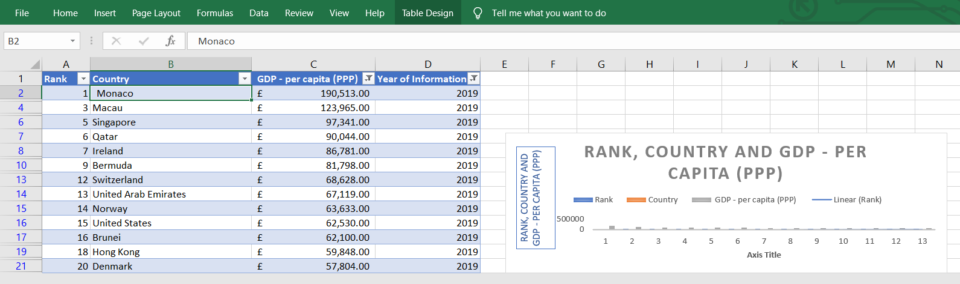

1. **Next create a new Bar chart to display the 20 highest ranking countries from your sort and then move the chart to be underneath the table, as shown below.**

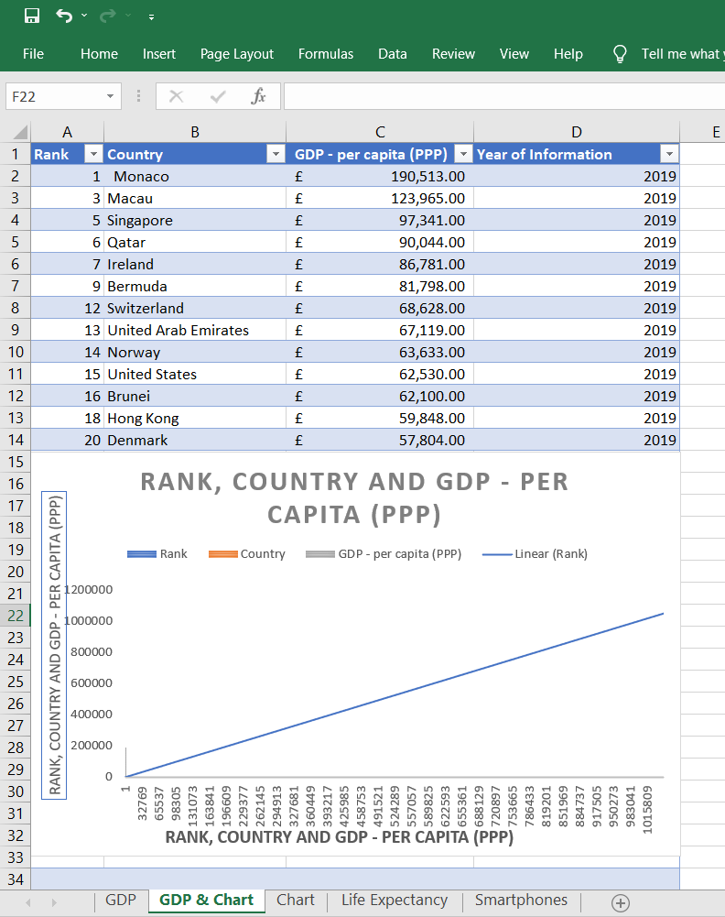

1. **Colour the background by highlighting the area underneath the table as shown below. Find the add a fill colour icon and sellect a colour.**

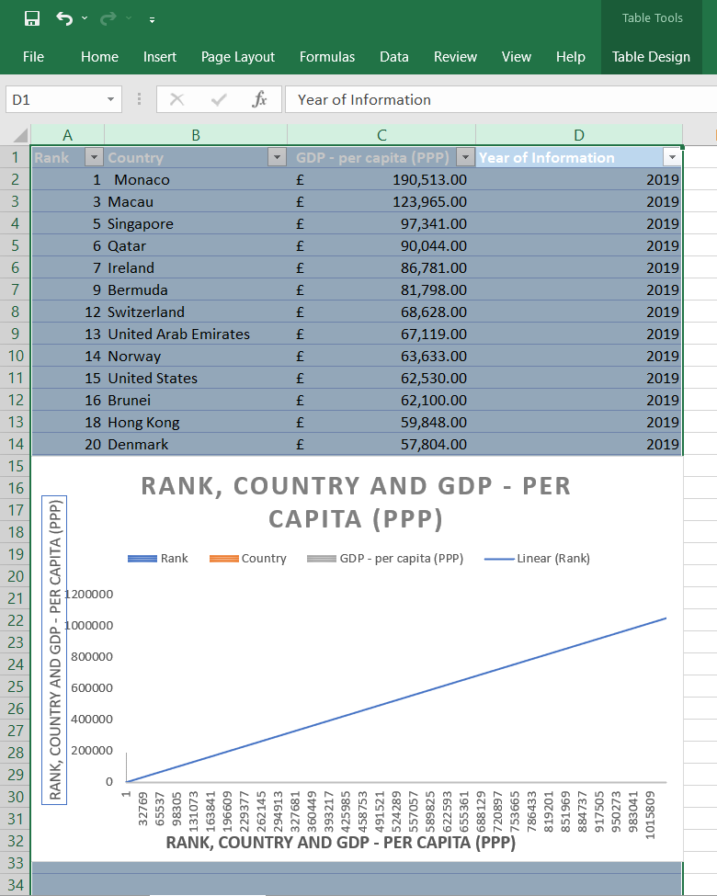

1. **The next task is to create 3 macro buttons, print the sheet, Save the file and copy the sheet.**

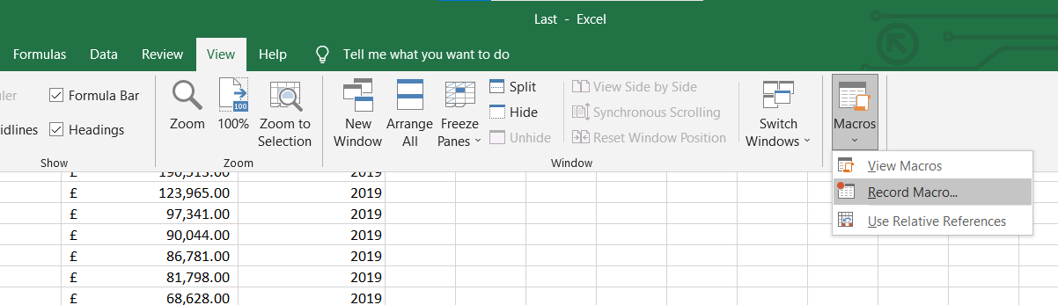

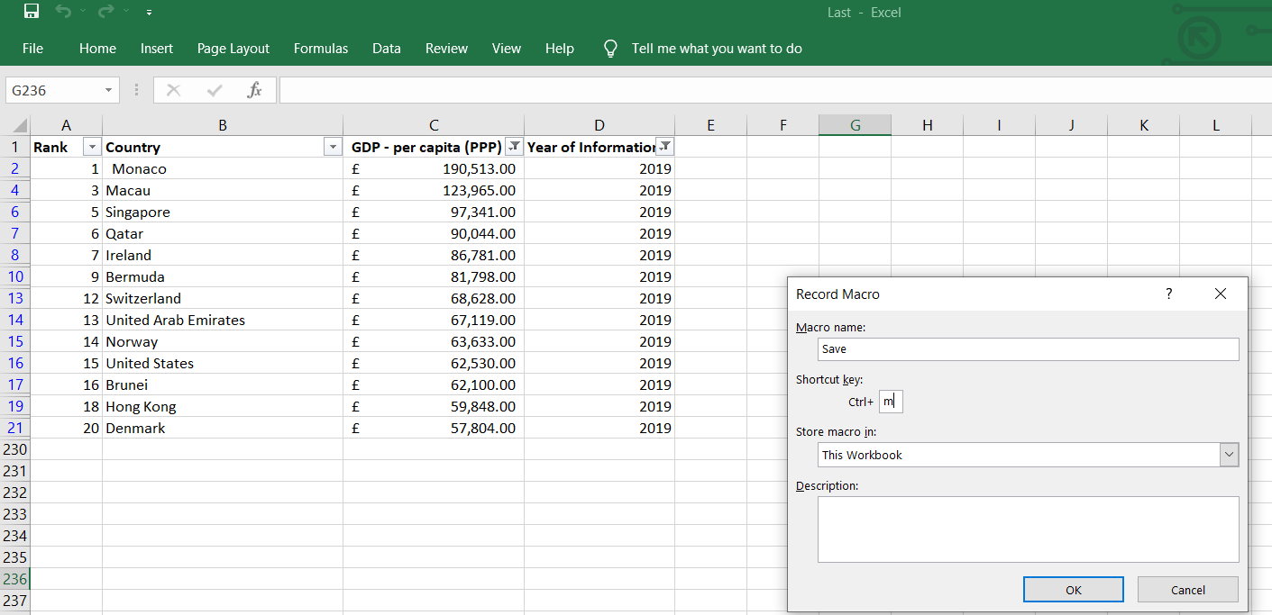

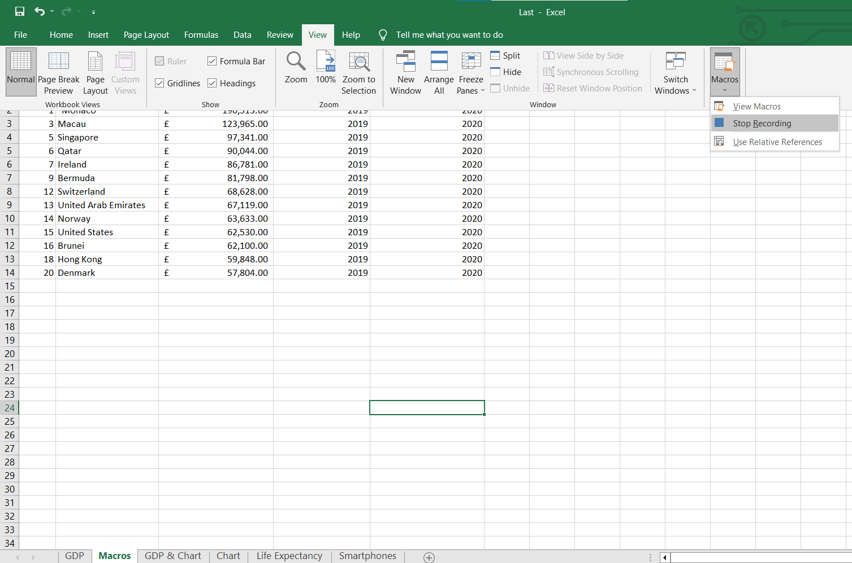

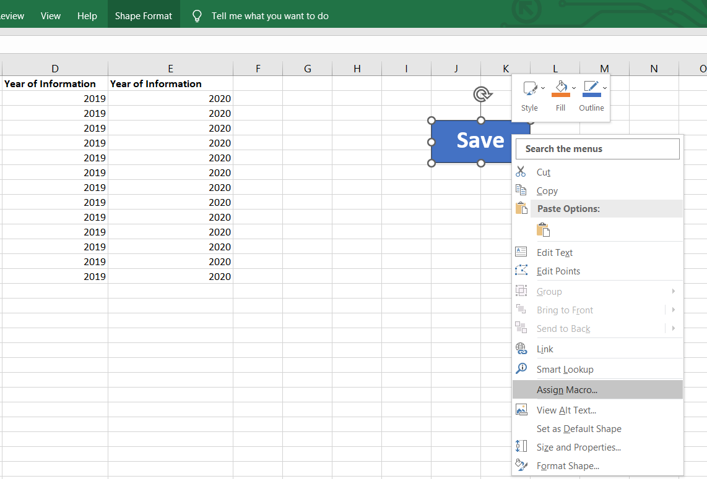

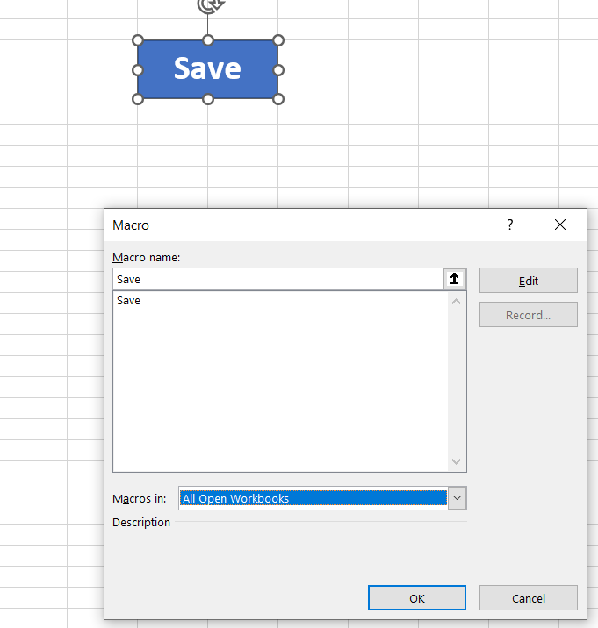

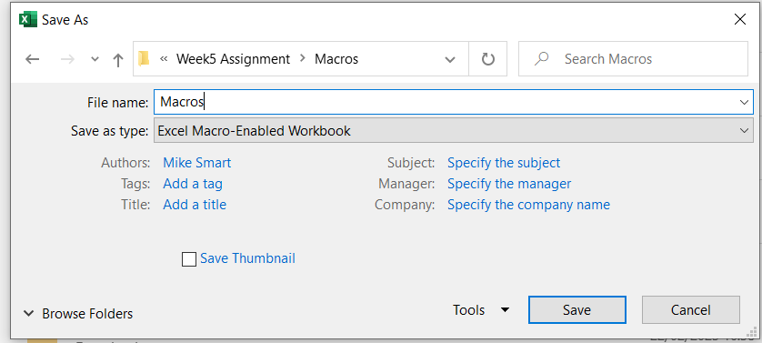

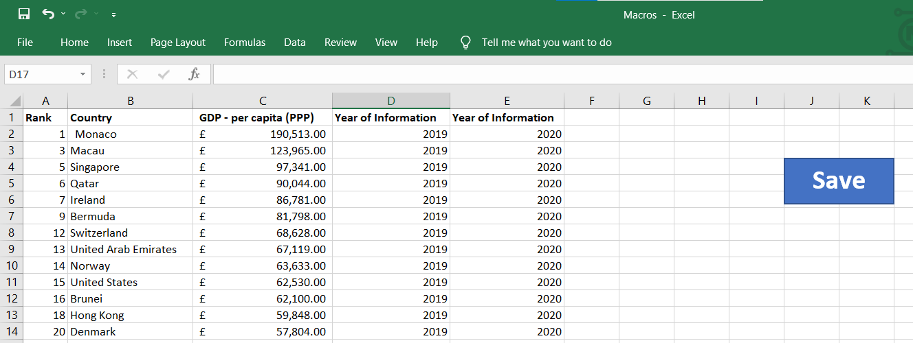

# **Third Task**

Continuing with the Excel table ‘The Wealth of nations’

## **Tableau**

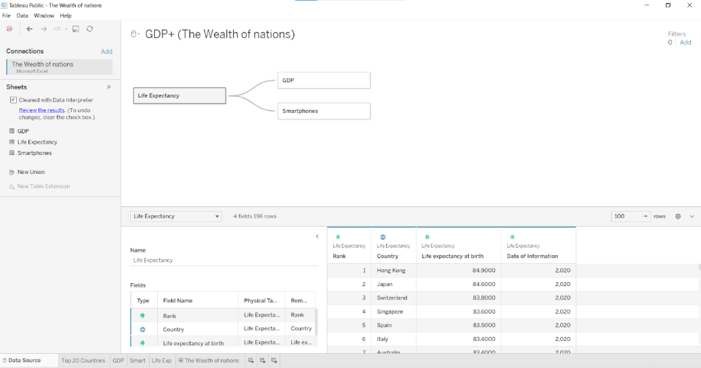

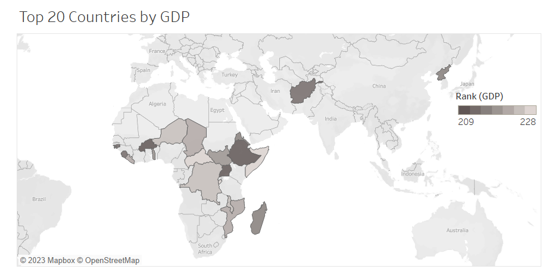

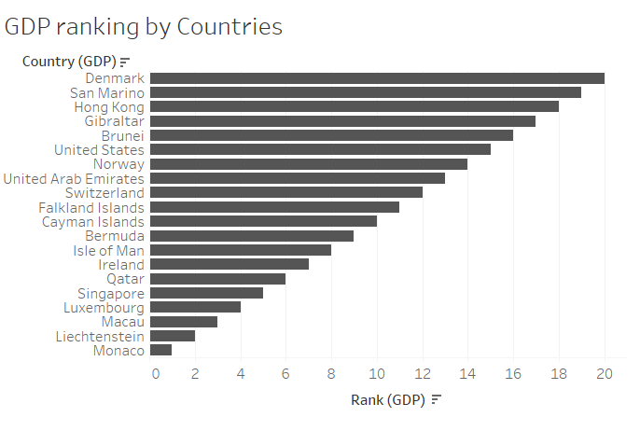

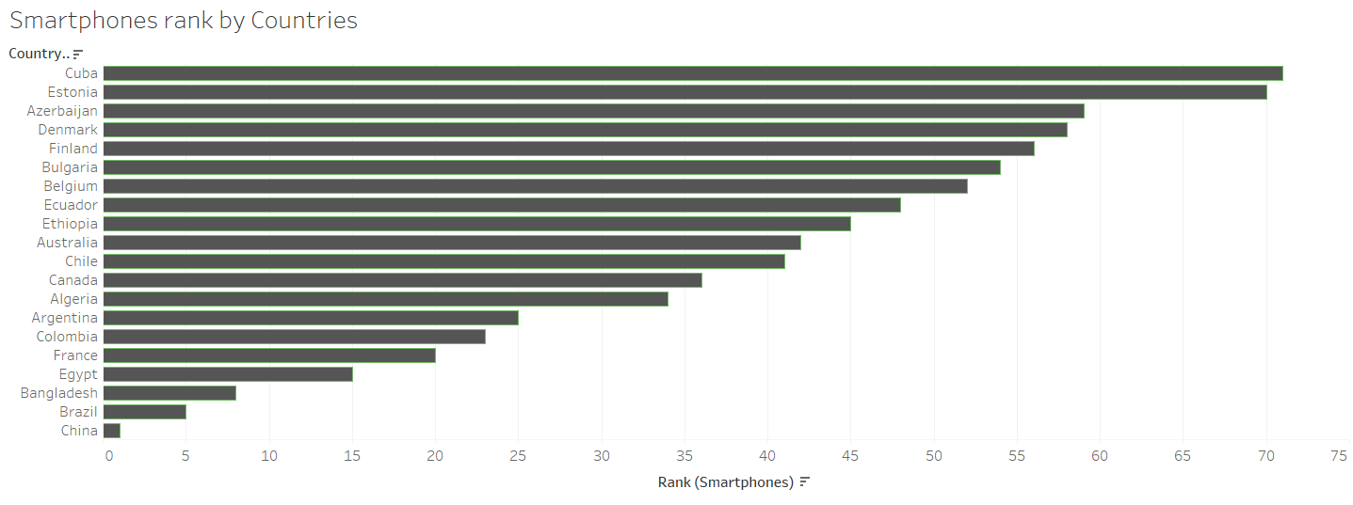

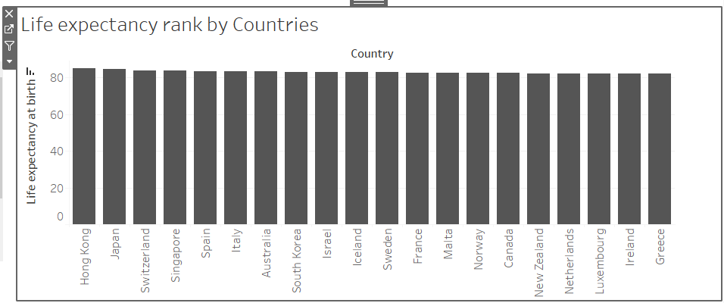

I have attached the excel worksheets and this is the link for the Tableau below [The Wealth of nations | Tableau Public](https://public.tableau.com/app/profile/reyad.hamza/viz/TheWealthofnations_16772505067150/TheWealthofnations?publish=yes).